**DESIGN AND IMPLEMENTATION OF A HYBRID INVERTER SYSTEM (5.5KVA) FOR ENGINEERING BLOCK ( GROUND FLOOR, 1st FLOOR, 2nd  FLOOR AND 3rd FLOOR )**

**BY**

**TAIWO AYODEJI OLUFEMI**

**CE/HND/PT/21011TA**

**DEPARTMENT OF COMPUTER ENGINEERING**

**SCHOOL OF ENGINEERING AND APPLIED SCIENCES**

**LAGOS CITY POLYTECHNIC, IKEJA,**

**LAGOS STATE**

**IN FUFILMENT OF THE REQUIREMENT FOR THE AWARD OF NATIONAL HIGHER DIPLOMA (HND) IN COMPUTER ENGINEERING**

**SEPTEMBER, 2023**

**CERTIFICATION**

This is to certify that this project was carried out and defended by OBASA ADEKUNLE NURUDEEN with Matric No: **CE/H/PT/21009OB** in fulfilment of the requirements for the award of Higher National Diploma (HND) in Computer Engineering under my supervision.

…………………………… ……………………………………….

OBASA ADEKUNLE NURUDEEN DATE Student .

…………………………… ……………………………………

ENGR. IGBABINI WILSON DATE

Project Supervisor

…………………………….. …………………………………

ENGR. ADELAJA TAIWO DATE

H.O.D Computer Engineering Dept.

**ACKNOWLEDGEMENT**

My appreciation goes to the entire management and staffs of Lagos City Polytechnic Ikeja for granting me the privilege to learn at this great citadel. The love and care, from the day of matriculation till this moment, we pray that the almighty God will continue to meet each and every one of you at the points of your need.

**DEDICATION**

This project is dedicated to God Almighty who walked me through this journey of study from the starting to the finishing stage.

**ABSTRACT**

This project is designed to increase the load estimation of lagos city polytechnic 2 engineering block, first and second floor, from 5kva to 10kva, from the inverter rating and serving time.

The type of inverter constructed is a pure sine wave inverter due to its advantages over other types of inverters. The true sine wave inverter is the most expensive and has the advantages of being versatile to the households, schools and office equipment.

The objective is to determine a load estimation that will help to design the upgrade of an inverter system with an output voltage the upgrade of an inverter system with an output voltage of 230v – 240v AC and a frequency of 50Hz. The system would be powered by a 48v battery which is to be charged by 400watts.

**TABLE OF CONTENTS**

Title page

Certification ……………………………………………………………………………………………... I

Acknowledgement ……………………………………………………………………………………… II

Dedication ………………………………………………………………………………………………..III

Abstract ………………………………………………………………………………………………….. IV

Table of Contents…………………………………………………………………………………….. ..V

**CHAPTER ONE**

INTRODUCTION

* 1. Background of the project ……………………………….……………………………………….1
  2. Aim and objective of the design …………………………………………………………….....1
  3. Scope of the design …………………………………………………………………………..2
  4. Significance of the design ………………………………………………………………………...2
  5. Limitation of the design ……………………………………………………………………………2
  6. Definition of terms ………………………………………………………………………………….2

**CHAPTER TWO**

LITERATURE REVIEW ........................................................................................4

2.1 History of inverter…………………………………………………………………………….. 4

2.2 Types of inverter………………………………………………………………….……………5

2.2.1 Modified Sine Wave Inverter………………………………………………………………5

2.2.2 Pure Sine Wave Inverter The Contactors ……………………………………………….6

2.2.3 Square wave inverters………………………………………………………………………6

**CHAPTER THREE**

3.0 METHODOLOGY OF THE DESIGN …………………………………………………………7

3.1 How to choose a right inverter and battery …………………………………………………..7

3.1 Load caculations .………………………………………………………………………..........7

3.2 Specifications of the inverter modules ………………………………………………………..8

3.3 Design Modules…………………………………………………………………………………...9

3.4 Principle of operation……………………………………………………………………………10

3.5 Charge controller (in built )…………………………………………………………………….16

3.6 Battery…………………………………………………………………………………………….17

**CHAPTER FOUR**

4.0 Testing of the design…..............................................................................................20

4.1 Installation procedures ……………………………...................................................20

4.2 Problems encountered and solutions……………………………………………………….22

4.3 Precaution taken during the design and installation ………......................................22

**CHAPTER FIVE**

5.1 Summary …………………………………………………………………………………..23

5.2 Recommendations ……………………………………………………………………….23

5.3 Conclusions………………………………………………………………………………...23

**CHAPTER ONE**

**INTRODUCTION**

**1.1 BACKGROUNG OF THE PROJECT**

Electric supply is one of the economic infrastructure facilities that are essential to a nation economic development. Power failure has resulted in people buying generator for their own daily activities, due to the erratic power supply people have resulted into use of generator set. This is the reason that necessitate the designing and construction of an inverter which can deliver the required electrical power standby to the load.

Inverters have become very important in modern technology because of the need to produce continuous supply of electric power to critical loads such as computer, surgical equipment, security doors, automated teller machine (ATM's), telecommunication and broadcast equipment, public address systems, rechargeable lambs etc. It is a major segment of an uninterrupted power supply units (UPS)

An inverter used for backup power in a grid connected home will use grid power to keep the batteries charged and when grid power fails it will switch to getting power from the batteries and supplying it to the buildings’ electrical system. Most modern inverters include over-voltage and under-voltage protection, thus protecting sensitive equipment from dangerous power surge.

The purpose of a DC/AC power inverter is typically to take DC power supplied by battery such as 12-volt car battery and convert it into a 220-240-volt AC power source operating at 50 Hz emulating the power available at an ordinary household electrical outlet.

Inverters are used in application such as: adjustable-speed Ac motor drivers, uninterrupted power supplies (UPS) and alternating current appliances. During the conversion process, the voltage is increased but due to Ohms law we know that an increase in voltage leads to a decrease in current, so the overall output current is decreased when the DC Signal is converted into an AC.

Inverter integrate different circuitries to automatically sense and tackle various situation that may occurs while the inverter is running or on standby mode. This automaton section looks after conditions such as overload, overheat, low battery, over-charge etc. Irrespective of the situation, the automation section may switch the battery to charging mode or stop the battery from charging when it is fully charged. The various conditions are indicated to the operator by means of glowing LEDs or sounding alarms. In advanced inverter LCD screens are used to visually indicate the conditions of the inverter [4].

**1.2 AIM AND OBJECTIVE OF THE DESIGN**

The primary aims & objectives of this project is to design and construct an 10kva powered solar inverter to power the engineering block of the school. The objectives are listed below:

1. To serve as backup power supply when the mains supply is being interrupted.
2. To produce a noiseless source of electricity generation which is eco-friendly.
3. To provide a source of electricity power with low maintenance cost.

**1. 3 SCOPE OF THE DESIGN**

The scope of this project is to design and construct an inverter with output rating of 10kVA, maximum output current of 22.72A, output voltage of 220V AC from a 24V input.

Inverter Rating - 10KVA

Battery (4) - 12V/200ah per one

Solar panel (4) - 200w,36V,5.56amps per one

Charge controller (PWM) - 24V,60amps.

**1.4 SIGNIFICANCE OF THE DESIGN**

The purpose of this project is to design an inverter which can be used to operate AC loads while eliminating the cost of running generators. Specifically, this study intends:

I. To design an inverter circuit with under voltage and over-voltage protection.

II. To provide a noiseless source of electricity.

III. To have a source of electricity that has no negative effect on the environment (i.e. Eco-friendly).

IV. To provide a source of electricity with low maintenance cost.

**1.5 LIMITATIONS OF THE DESIGN**

Every design/project always has its own limitation. The limitation of this project is:

1. Inferior component in the market
2. Main power supply interruption
3. The input is limited to 24V DC, output to 230VAC and the frequency 50Hz
4. The inverter nearly got burnt due to the inferior Transformer used in the inverter.
5. Main power supply interruption.
6. Lack of financial assistance which led to the delay of the project.
   1. **DEFINITION OF TERMS**

* **Direct Current**: Is the unidirectional flow of electric charge.
* **Alternate Current:** Is an electric current which periodically reverses direction
* **Capacitor:** A passive electronic-circuit component consisting of, in basic form, two metal electrodes or plates separated by a dielectric (insulator).
* **Inverter:** Is an electronic device or circuitry that changes direct current (DC) to alternating current (AC).
* **Resistor:** These are electronic components that are used for limiting current flow for a specific value. They are also used to provide a desired voltage drop.
* **Relay:** These are electromagnetic devices used in operating switches. They have the ability of sensing faults, signal variation reactions and pass this information to the switches. This is an electromagnetic switch.
* **Transistor:** This is an electronic component that controls electric current as it passes through a circuit and also serves as a switch.
* **Transformer:** Is a device used in increasing and decreasing voltage without change in frequency. It only works with AC; it is not sensitive to DC.
* **MOSFET** (Metal Oxide Semi-Conductor Field Effect Transistor): the MOSFET is a power amplifier, it switched ON and OFF by the transistor (BJT) and sends square alternative pulses to the secondary transformer.
* **Battery:** Is a device that consists of one or more electrochemical cells that converts stored chemical energy into useful electrical energy. It produces direct current.
* **Charge Controller:** It controls the rate at which battery charges and discharges.

**CHAPTER TWO**

**LITERATURE REVIEW**

**2.1 HISTORY OF INVERTER**

The [photovoltaic effect](http://en.wikipedia.org/wiki/Photovoltaic_effect) was first experimentally demonstrated by French physicist [Edmond Becquerel](http://en.wikipedia.org/wiki/Edmond_Becquerel). In 1839, at age 19, he built the world's first photovoltaic cell in his father's laboratory. [Willoughby Smith](http://en.wikipedia.org/wiki/Willoughby_Smith) first described the "Effect of Light on Selenium during the passage of an Electric Current" in a 20 February 1873 issue of [Nature](http://en.wikipedia.org/wiki/Nature_%28magazine%29). In 1883 [Charles Fritts](http://en.wikipedia.org/wiki/Charles_Fritts) built the first [solid state](http://en.wikipedia.org/wiki/Solid_state_%28electronics%29) photovoltaic cell by coating the [semiconductor](http://en.wikipedia.org/wiki/Semiconductor)[selenium](http://en.wikipedia.org/wiki/Selenium) with a thin layer of [gold](http://en.wikipedia.org/wiki/Gold) to form the junctions. The device was only around 1% efficient. In 1888 Russian physicist [AleksandrStoletov](http://en.wikipedia.org/wiki/Aleksandr_Stoletov) built the first cell based on the outer [photoelectric effect](http://en.wikipedia.org/wiki/Photoelectric_effect) discovered by [Heinrich Hertz](http://en.wikipedia.org/wiki/Heinrich_Hertz) in 1887.

[Albert Einstein](http://en.wikipedia.org/wiki/Albert_Einstein) explained the underlying mechanism of light instigated carrier excitation—the [photoelectric effect](http://en.wikipedia.org/wiki/Photoelectric_effect)—in 1905, for which he received the [Nobel Prize in Physics](http://en.wikipedia.org/wiki/Nobel_Prize_in_Physics) in 1921. [Russell Ohl](http://en.wikipedia.org/wiki/Russell_Ohl) patented the modern junction semiconductor solar cell in 1946, discovered while working on the series of advances that would lead to the [transistor](http://en.wikipedia.org/wiki/Transistor).

The first practical photovoltaic cell was publicly demonstrated on April 25, 1954 at [Bell Laboratories](http://en.wikipedia.org/wiki/Bell_Laboratories). The inventors were Daryl Chapin, [Calvin Souther Fuller](http://en.wikipedia.org/wiki/Calvin_Souther_Fuller) and [Gerald Pearson](http://en.wikipedia.org/wiki/Gerald_Pearson).

Solar cells gained prominence when they were proposed as an addition to the 1958 [Vanguard I](http://en.wikipedia.org/wiki/Vanguard_I) satellite. By adding cells to the outside of the body, the mission time could be extended with no major changes to the spacecraft or its power systems. In 1959 the United States launched [Explorer 6](http://en.wikipedia.org/wiki/Explorer_6), featuring large wing-shaped solar arrays, which became a common feature in satellites. These arrays consisted of 9600 [Hoffman solar cells](http://en.wikipedia.org/wiki/H._Leslie_%28Les%29_Hoffman).

Improvements were gradual over the next two decades. The only significant use was in space applications where they offered the best [power-to-weight ratio](http://en.wikipedia.org/wiki/Power-to-weight_ratio). However, this success was also the reason that costs remained high, because space users were willing to pay for the best possible cells, leaving no reason to invest in lower-cost, less-efficient solutions. The price was determined largely by the semiconductor industry; their move to [integrated circuits](http://en.wikipedia.org/wiki/Integrated_circuit) in the 1960s led to the availability of larger [boules](http://en.wikipedia.org/wiki/Boule_%28crystal%29) at lower relative prices. As their price fell, the price of the resulting cells did as well.

**Berman's price reductions**

In the late 1969, Elliot Berman was investigating organic solar cells, when he joined a team at [Exxon](http://en.wikipedia.org/wiki/Exxon) SPC who were looking for projects 30 years in the future. The group had concluded that electrical power would be much more expensive by 2000 and felt that this increase in price would make alternative energy sources more attractive, finding solar the most interesting..

The first improvement was the realization that the standard semiconductor manufacturing process was not ideal. The team eliminated the steps of polishing the wafers and coating them with an anti-reflective layer, relying on the rough-sawn wafer surface. The team also replaced the expensive materials and hand wiring used in space applications with a [printed circuit board](http://en.wikipedia.org/wiki/Printed_circuit_board) on the back, [acrylic](http://en.wikipedia.org/wiki/Acrylic) plastic on the front, and [silicone](http://en.wikipedia.org/wiki/Silicone) glue between the two, "potting" the cells. Solar cells could be made using cast-off material from the electronics market.

The company started buying up "reject" silicon at very low cost. They used the largest wafers available, thereby reducing the amount of wiring for a given panel area and packaged them into panels.

**Applications**

Solar cells are often encapsulated as a module. Photovoltaic modules often have a sheet of glass on the sun-facing side, allowing light to pass while protecting the semiconductor [wafers](http://en.wikipedia.org/wiki/Wafer_%28electronics%29). Solar cells are usually connected in [series](http://en.wikipedia.org/wiki/Series_and_parallel_circuits) in modules, creating an additive [voltage](http://en.wikipedia.org/wiki/Voltage). Connecting cells in parallel yields a higher current; however, problems such as shadow effects can shut down the weaker (less illuminated) parallel string (a number of series connected cells) causing substantial power loss and possible damage because of the [reverse bias](http://en.wikipedia.org/wiki/Reverse_bias) applied to the shadowed cells by their illuminated partners. Strings of series cells are usually handled independently and not connected in parallel, though (as of 2014) individual [power boxes](http://en.wikipedia.org/wiki/Electric_power_conversion) are often supplied for each module, and are connected in parallel. Although modules can be interconnected to create an **array** with the desired peak DC voltage and loading current capacity, using independent MPPT ([maximum power point trackers](http://en.wikipedia.org/wiki/Maximum_power_point_tracking)) is preferable. Otherwise, shunt [diodes](http://en.wikipedia.org/wiki/Diode) can reduce shadowing power loss in arrays with series/parallel connected cells.

**2.2** **TYPES OF INVERTER**

There are three different types of inverter based on their output waveform:

* Modified Sine Wave inverter
* Pure Sine Wave (True Sine Wave)
* Square Wave inverter

**2.2.1 Modified Sine Wave Inverter**

A modified sine wave is like a square wave but instead has a stepping look to it that relates more in shape to a sine wave. The waveform is easy to produce because it is just the product of switching between three values at set frequencies, thereby leaving out the more complicated circuitry needed for a pure sine wave hence provides a cheap and easy solution to powering devices that need AC power. However, it does have some drawbacks as not all devices work properly on a modified sine wave, product such as computers and medical equipment are not resistant to the distortion of the signal and must be run off a pure sine wave power source Modified sine wave inverters approximate a sine wave and have low enough harmonics that do not cause problem with household equipment. The main disadvantage of the Modified sine wave inverter is that peak voltage varies with the battery voltage [8].

# C:\Users\stonekay\AppData\Local\Microsoft\Windows\INetCache\Content.Word\Capture2.png

**Fig 1: Modified sine wave form**

**2.2.2 Pure sine wave inverter**

Pure sine wave inverter represents the latest inverter technology. The waveform produced by these inverters is same as or better than the power delivered by the utility. Usually sine wave inverters are more expensive than the modified sine waves inverters due to their added circuitry. The electrical output of pure sine wave inverters is far more complex than a square wave or modified sine inverter. A pure sine wave has more efficiency; hence it consumes less power and it can be adjusted according to personal power requirements (9).

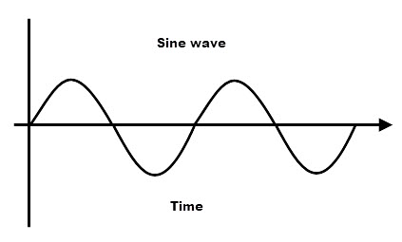

**Fig 2: Pure Sine wave form**

**2.2.3 Square wave inverters**

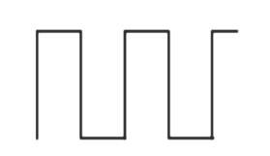A square wave inverter is one of the simplest inverter types, which converts a straight DC signal to a phase shifting AC signal. But the output is not pure AC, i.e. in the form of a pure sine wave but it is a square wave. At the same time, they are cheaper, and the simplest construction of a square wave can be achieved by using an on-off switch, before a typical voltage amplifying circuit like a transformer (10).

**Fig 3: Square wave form**

**CHAPTER THREE**

**3.0 METHODOGY OF THE DESIGN**

The purpose of this project is to design an inverter system that power AC loads in the Engineering block, while minimizing the cost of generator maintenance and fuel. This chapter describes the method employed in constructing this project. It covers all aspect of the project design.

A major factor in the design of this project is the nature of the load to be carried power to be supplied and the charging current in respect to their time (Ah) which may be determined by the battery capacity and its total output power.

## 3.1 [HOW TO CHOOSE A RIGHT INVERTER AND BATTERY](http://tekinsider.wordpress.com/2010/04/07/how-to-choose-a-right-inverter-and-battery/)

Inverter is a type of electronic power generator which convert low voltage direct current (DC) from a battery to a high voltage alternating current (AC). Power failures can be very frustrating at times, especially during the night-time. Inverters will help you to cope up with the blackout and do away with your problems. Choosing a right inverter and battery is not very easy.

**Load Calculation:** First, calculate your Power Consumption. This can be done by adding up the Watts (W) of all loads (CFLs, TV.), to be powered by the inverter. For example, one 20W CFL + one 60W TV =20+60 =80W.

**Inverter Capacity:** Never select the Volt-Ampere (VA) rating of Inverter. VA=Watts x Power Factor. Power factor value varies from 0.6 to 0.8. Note that a 600VA rated inverter (with power factor 0.8) delivers approximately 480 Watts only!

**Inverter Type:** Square wave, Quasi- Sine wave and Pure Sine wave inverters are now available. In practice, sine wave is the correct waveform on which all electronic equipment, including televisions and computers are designed to run.

**Battery Selection:** Battery is the backbone of any inverter. Usually 12V battery is used with home inverters. Tubular type storage batteries are recommended for inverters because they are capable of long hours of guaranteed backup time. Backup time is simply the number of hours for which an inverter will be able to run the output electric load during power failure. Batteries are available in different voltage and Ampere-Hour (Ah) ratings. Back up time is mainly determined by this Ah rating of the battery. Tubular batteries have higher capacity-to-size ratio. These types can be recharged faster and are energized to deliver increased power and higher efficiency.

**Backup Time:** Formula to Calculate the backup time of Inverter is:

(Batteries Voltage, V x Ah of batteries) / Load (W) = WH/W= H

**3.1 LOAD CALCULATIONS**

The load calculations of the engineering block are stated as follows:

**First floor**

|  |  |  |  |  |
| --- | --- | --- | --- | --- |
| **S/N** | **Load** | **Quantity** | **Power (W)** | **Total**  **(W)** |
| 1. | Lightening points | 18 | 60 | 1080 |
| 2. | Fans | 9 | 70 | 630 |
|  | **Total** | | | **1710** |

**Second Floor**

|  |  |  |  |  |
| --- | --- | --- | --- | --- |
| **S/N** | **Load** | **Quantity** | **Power (W)** | **Total**  **(W)** |
| 1. | Lightening points | 18 | 60 | 1080 |
| 2. | Fans | 9 | 70 | 630 |
|  | **Total** | | | **1710** |

**Third Floor**

|  |  |  |  |  |
| --- | --- | --- | --- | --- |
| **S/N** | **Load** | **Quantity** | **Power (W)** | **Total**  **(W)** |
| 1. | Lightening points | 18 | 60 | 1080 |
| 2. | Fans | 9 | 70 | 630 |
|  | **Total** | | | **1710** |

Total load demand = First floor + Second floor+ Third floor

= 1710 + 1710 + 1710

= 5130W

= 5.13KW

Where 0.8 is the power factor used

= 5130WRequired/0.8

= 6,412.W

1. **Inverter rating:**

5.5Kva

This is the rating of inverter; we need 5.5Kva inverter for solar panel installation according to our need (based on calculations).

1. **Backup hours of batteries (4 Batteries)**

The required back up time of batteries in hours = hours

Rating of the Batteries Per one = 12V 220Ah

Because this is a 48V inverter system, so if we connect these 4 set batteries in series , then the rating of the batteries become = 12V (4 Batteries)

While the charging current rating will now be 880Ah

48V x 880Ah = 42,240wh/ 5130W = 8.2 hours

We will now connect 4 set batteries in series (each of 220Ah, 48V) i.e. 4 numbers of 12V = 48V, 880Ah

1. **Charging current for batteries**

Charging current should be 1/ 10 of batteries

400Ah x 1/ 10 = 40A

1. **Charging time required for battery**

Here is the formula of charging time of a lead battery

Charging time of battery = battery Ah/ Charging current

T= Ah/ A

T = 400Ah/ 40A = 10hours

**3.2 SPECIFICATIONS OF THE INVERTER MODULES**

**Inverter**

Type: Pure sine wave

Rating: 48V/ 5.5KVA

**3.3 Design Modules**

There are five (2) modules to this inverter installation, each of these modules have their varying functions in the working of the inverter. These modules include:

* Battery unit and
* Inverter

The inverter is to be powered by the battery, the battery which would in-turn need to be recharged is charged by the solar panel. The charging cycle of the battery is monitored by the charge controller, the charge controller would prevent over charging and protect against over voltage. The automatic changeover maintains switching supply of power between inverter and NEPA i.e. when there is power outage from NEPA, the change-over automatically switches over to inverter and when NEPA restores power, it switches back to NEPA.

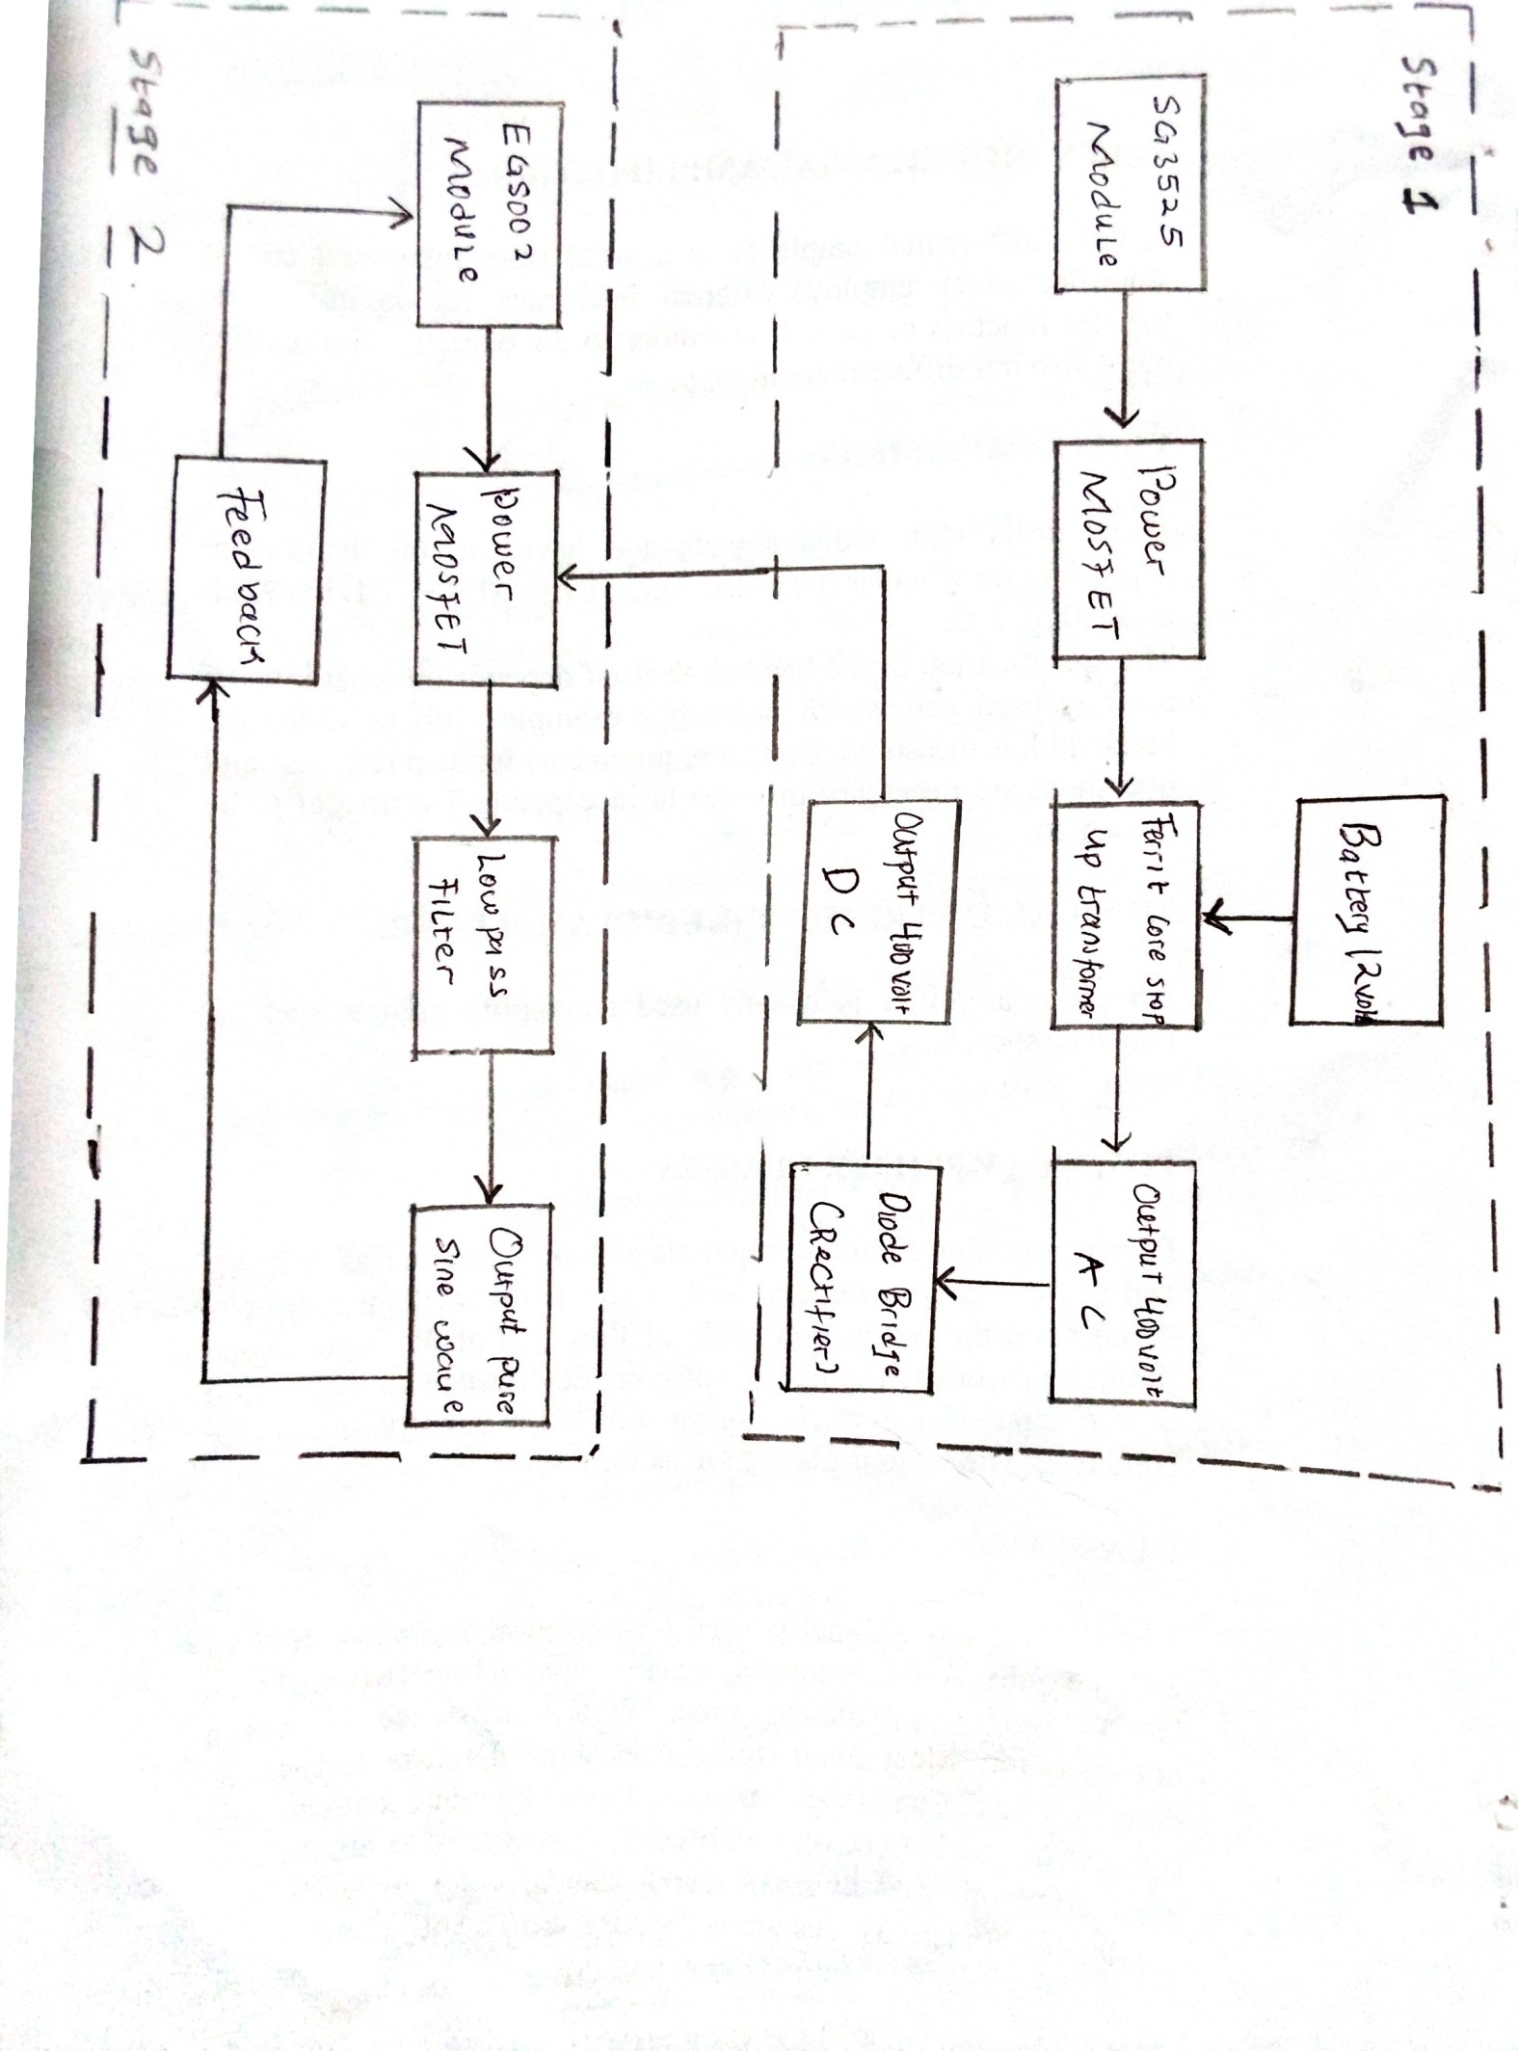

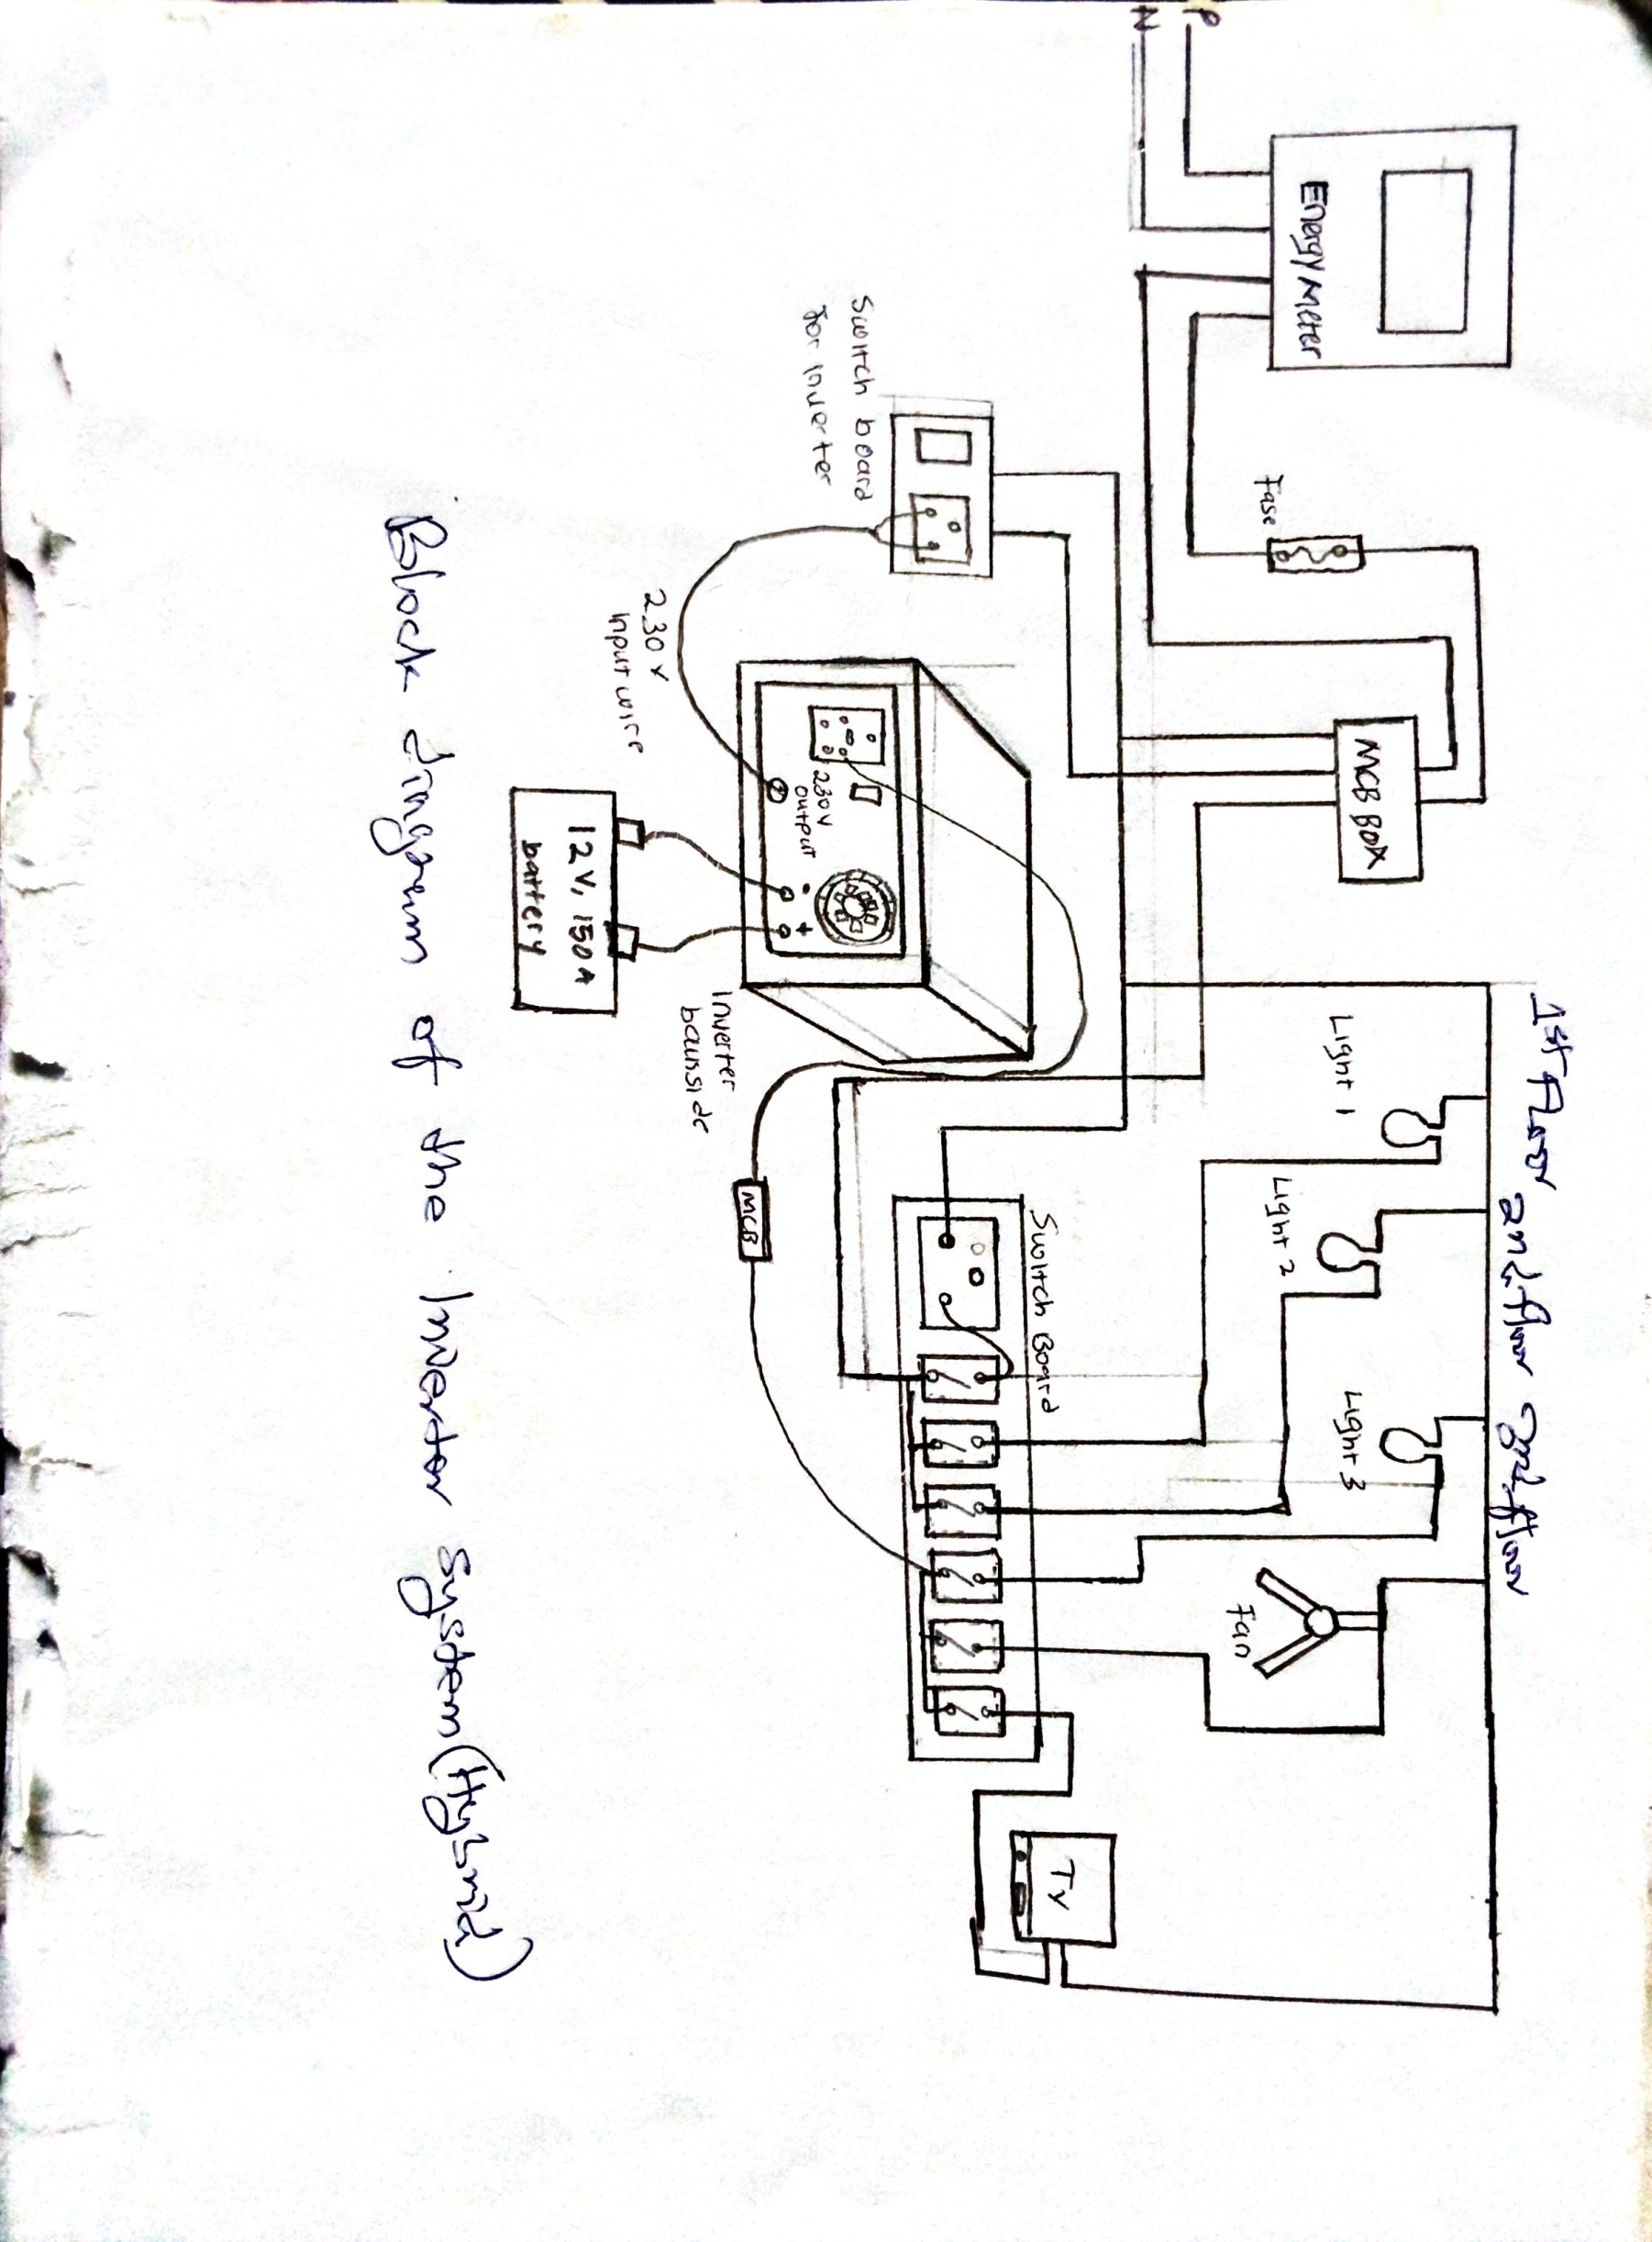

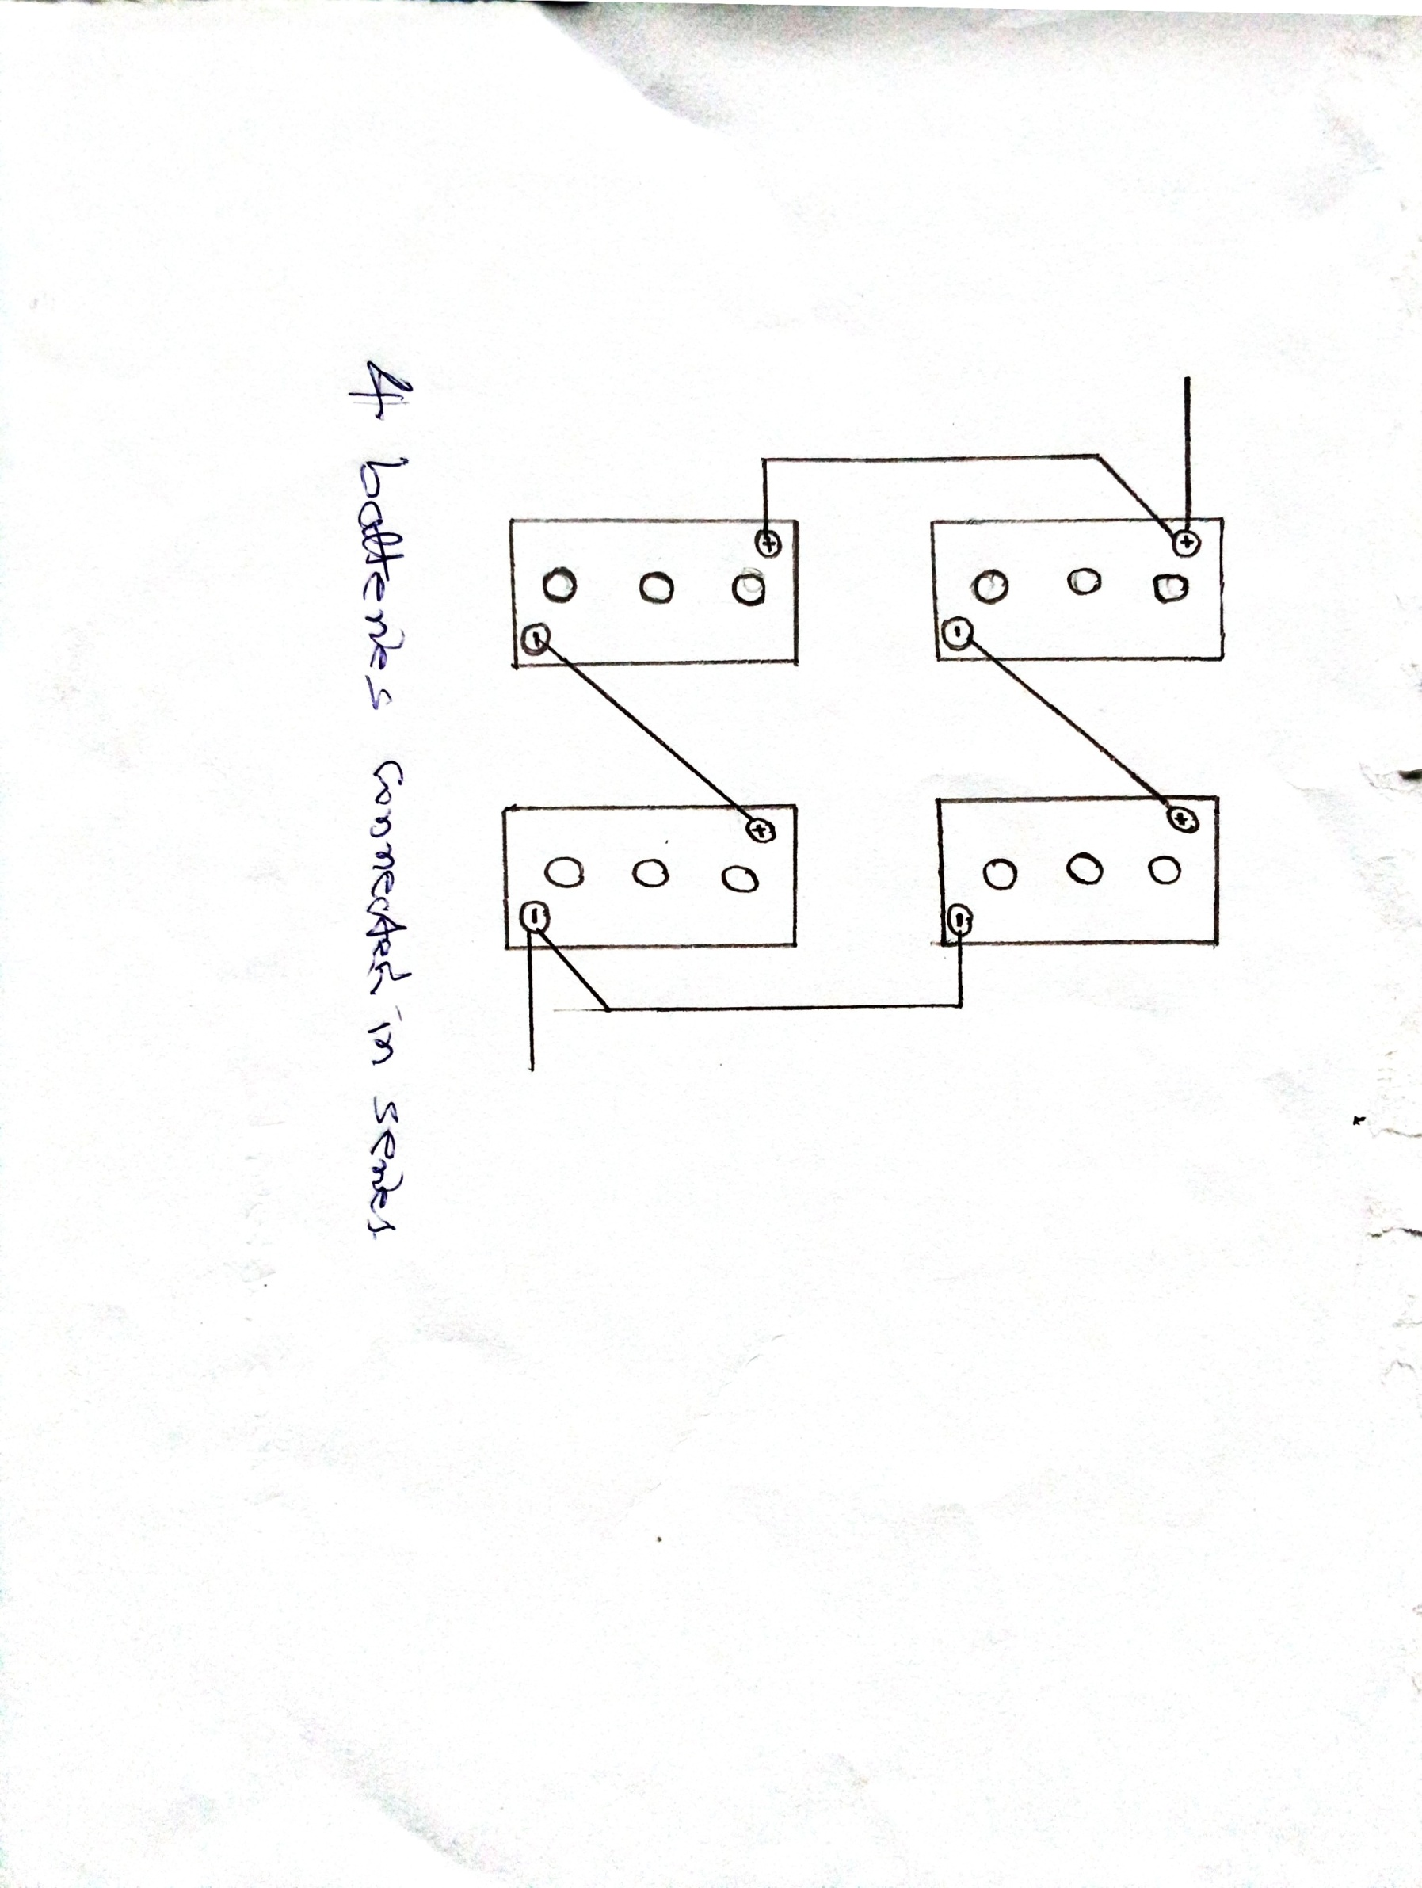

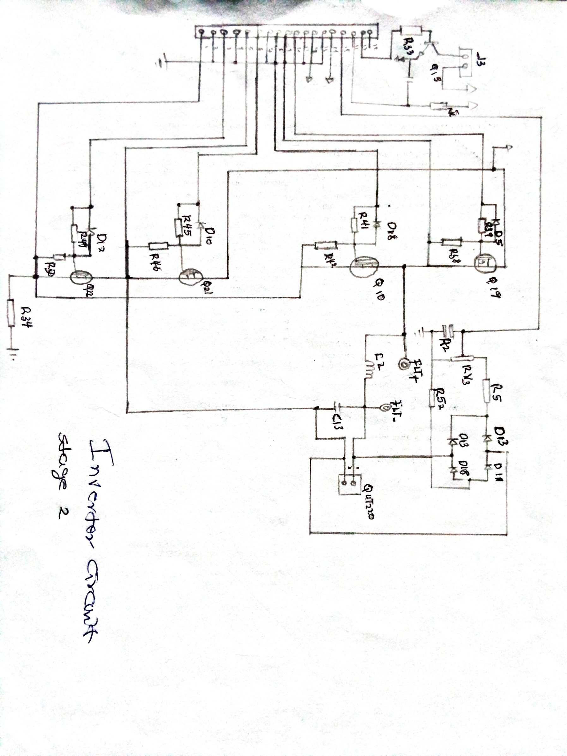

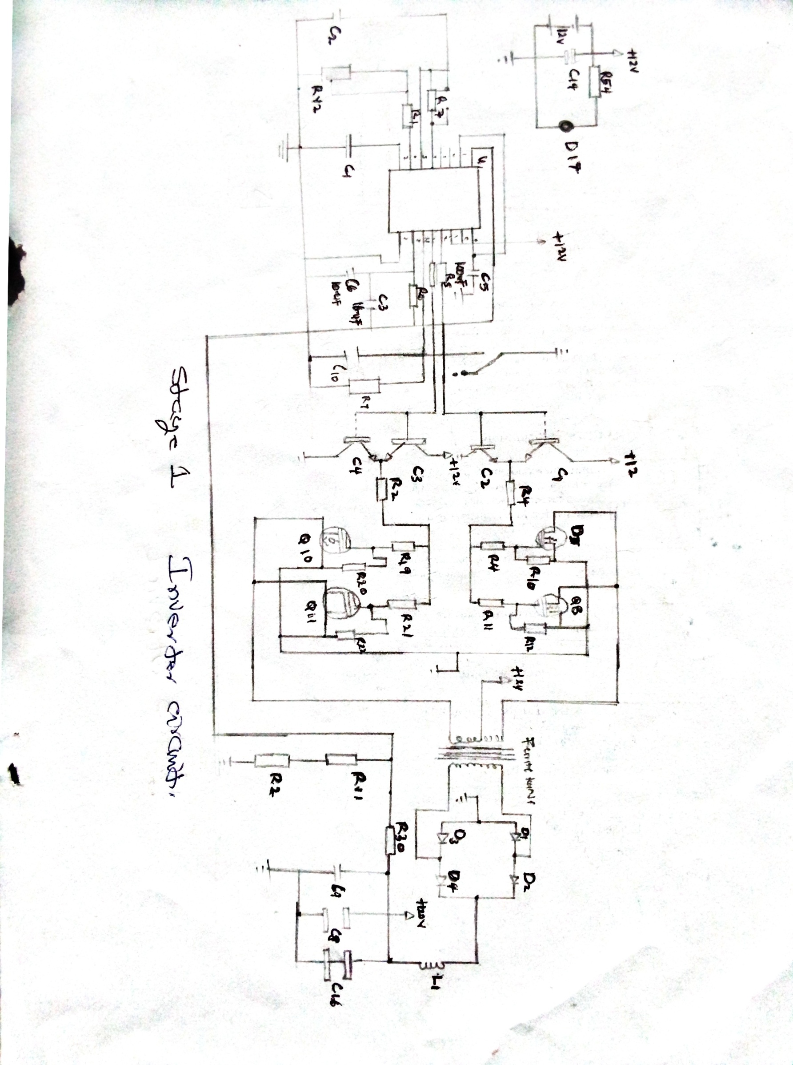

**3.4 PRINCIPLE OF OPERATION**

The Inverter Circuit consists of two circuit blocks,namely the stage 1and the stage 2.The stage 1 consists of consist of 12volts battery, EGS002 module, MOSEFT, ferrite core step-up transformer and rectifier diode. Meanwhile, stage 2 consist of the EGS002 module, MOFSET, low pass filter and feedback.

The SG3525 module functions as a square wave frequency generator. The MOSFET power amplifier functions as an inverter power amplifier. The ferrite transformer functions as a voltage boost from 48volts to 400volts. The bridge rectifier diode functions to rectify the 400volts AC to DC. The EGS002 functions as a control chip to generate a pure sine PWM signal. The pure sine voltage generated from the 400volts DC voltage as the output of the stage 1circuit, is passed through the stage 2 MOSFET circuit with the EGS002 controller. The final output of the circuit is passed through a low-put filter circuit as to produce a pure sine voltage. Feedback is used to control the inverter output voltage stable at 220volts AC.

III.1.The First Stage of Inverter Circuit

The stage 1 circuit as shown is a circuit that functions to produce a high voltage inverter, converting from DC 12volts to DC 400volts. The 400volts DC voltage is used as the input voltage for the stage 2 circuit which is then processed into a pure sine wave voltage.

III.2.The Second Stage of Inverter Circuit

The stage 2 circuit in functions as a PWM signal generator which generates a pure sine wave. T his circuit consist of three four blocks, namely the EGS002 module as a PWM generator, a high voltage MOSFET as a power amplifier, a filter, an a feedback circuit. The EGS002 module as a PWM signal generator module produce a outputs 1H1, 1LO, 2HO, 2LO. These output pins are connected to the IRFP460 high-voltage MOSFET circuit. Furthermore, the output voltage of the MOSFET, which is arranged in a full bridge configuration, is still in the form of square wave PWM. Finally, this signal is filtered by a 3.3uH inductor and a 2.2uH/400volt capacitor to produce a pure sine wave. The feedback circuit which is arranged using a rectifier diode and a capacitor is used as a controller so that the output voltage remains stable at a voltage of 220volts AC.

**3.3.3**  **CHARGE CONTROLLER(In built)**

Pulse width modulation (PWM) charge controller is the most effective means to achieve constant voltage battery charging by adjusting the duty radio of the switches (MOSFET). In PWM charge controller, the current from the solar panel tapers according to the battery’s condition and recharging needs. When a battery voltage reaches the regulations set point, the PWM algorithm slowly reduces the charging current to avoid heating and gassing of the battery; yet charging continues to return the maximum amount of energy to the battery in the shortest time. The voltage of the array will be pulled down to near that of the battery. There are 3-stages to the charging cycle of the battery:

**3.3.4 BATTERY**

A Battery is device that consists of one or more electrochemical cells that convert stored chemical energy into useful electrical energy. Each cell contains a positive terminal and a negative terminal.

The runtime of an inverter is dependent on the battery power and the amount of power being drawn from the inverter at a given time. The type of battery used here is a lead acid battery because they are the best type of batteries to be used in photovoltaic systems, due to their wide availability in many sizes, the rating of battery used here is a 24V, 400Ah.

**3.4 WORKING PRINCIPLE OF THE INVERTER**

Inverter is a key system element that is used for power conditioning, taking a closer look at the physical principles used by inverters to produce their output signals. The process of an inverter converting DC into AC is based on the phenomenon of **electromagnetic induction.** Electromagnetic induction is the production of an electromotive force (i.e. voltage) across an electrical conductor in a varying magnetic field.

To produce a sine wave output, inverters with high frequency is used. The inverter uses **Pulse Width Modulation method;** switching currents at high frequency and for varying periods of time.

**IN INVERTER MODE;** as soon as mains fails, the battery logic is detected a pin #22 of the PIC which instantly prompts the controller section to switch the system in the inverter/battery mode. In this mode, the controller begins to generate the required PWM via pin#13, however, the PWM generation rate is implemented only after the controller confirms the logic level at pin#15 (INV/UPS switch).

If a high logic is detected at pin#15 (INV mode) the controller initiates a fully modulated cycle while is around 70%, and in case of a low logic at pin#15 of the PIC, then the controller is prompted to generate burst of PWM ranging from 1% to 70% at a rate of 250ms period, which is termed as soft delay output while in the UPS mode. The controller simultaneously with the PWM also generate a “channel select” logic through pin#13 of the PIC which is further applied to pin#8 of IC CD4081.

Throughout initial time period of the pulse (i.e. 10ms) the pin#12 of the PWM controller is rendered high such that the PWM can be obtained from pin#10 of CD4081 exclusively and after 10ms, pin#14 of PIC is set to high logic and the PWM is accessible from pin#11of CD4081, as a result, using this method a pair of anti-phased PWM becomes accessible to switch on the MOSFET. A high +5V becomes accessible from pin#11 of the PWW controller, this pin turns high each time inverter is ON and ends up being low whenever inverter is OFF. This high logic is applied to pin#10 of each of the MOSFET drivers U1 and U2.

**MOSFET SWITCHING;** in the MOSFET switching, U1 (IR2110) and U2 (IR2110) high slide/ low side MOSFET drivers are employed, in this, the two MOSFET banks are intended for transformer’s primary side switching. As soon as the inverter is ON the PIC renders the pin#10 of U1 to logic high which subsequently activates the high side MOSFET (M1-M4) ON, PWM For channel-1 from pin#10 of CD4081 is applied to pin#12 of the driver IC (U1) and likewise it is administered to the base of Q1 via R25.While the PWM is logic high, the pin#12 of U1 is also logic high and triggers a low side MOSFET of bank (M9-M12), alternately it launches the transistor Q1 which correspondingly renders the pin#10 voltage of U1 logic low, thereby turning OFF the high side MOSFET (M1-M4).

Therefore, it implies that by default the high the logic from pin#11 of the PIC gets switched ON for the high side MOSFET among the two mosfet arrays, and while the associated PWM is high, the low side MOSFET are switched ON and the high side MOSFET are switched OFF and through this way the switching sequence keeps repeating.

**MOSFET switching protection;** pin#11 of U1 is used for executing the hardware lock mechanism of each of the driver’s unit. By standard fixed mode; this pin fixed with a low logic, but whenever under any circumstances the low side MOSFET switching fails to initiate, the voltage of low side MOSFET can be expected to shoot up which immediately causes the output pin#1 of comparator U4 to go high and become latched with the help of D27 and render pin#11 of U1 and U2 high, and thereby toggle OFF the two MOSFET driver stages effectively, Preventing the MOSFET from getting burnt and damaged.

Pin#8 and pin#9 of U1 and U2 is of +VCC of the IC (+5V) pin#3 of U1 and U2 is of +12v for MOSFET gate drive supply, pin#7 is the high side MOSFET gate drive, pin#5 is the high MOSFET receiving route, pin#1 is the low side MOSFET drive, and pin2 is the low side MOSFET receiving path. Pin#13 is the ground of the IC (U1).

**OVER-LOAD PROTECTION;** In order to cut-off inverter from the load in the event the load goes beyond the safe load specifications, the battery current is first detected across the negative line (i.e. the voltage drop across the fuse and negative path of the low side MOSFET bank) and this greatly reduced voltage (in mV) is proportionately intensified by the comparator U5 (comprising of pins12, 13 and 14). This amplified output from pin#14 of U5 is rigged as inverting is amplifier and applied to pin#7 of the micro-controller. The software compares the voltage with reference, which is for this particular pin is 2V, the controller senses the voltage in this pin besides operating system in the inverter-mode, every time the load current arguments, the voltage at this pin builds up, whenever the voltage on pin#7 of the controller IC is above 2V the process shuts down the Inverter and switches to overload mode, shutting down the inverter, turning ON the overload LED and causing the buzzer to deep which after 9-beeps prompts the inverter to switch – ON again.

**CHAPTER FOUR**

**TESTING AND INSTALLATION**

**4.0 TESTING OF THE DESIGN**

Various testing procedures were carried out on the entire system to detect and correct any fault that may occur in the system. It is proper that after construction, a careful testing of the output of each stage is carried out. This is to confirm that it conforms to the required output.

**Test for inverter output**

* The inverter is tested to ensure that it powers ON.
* The inverter transformer is tested to ensure that it is conformity with the required expected output voltage.
* The output voltage, current, power and frequency of components in the inverter were measured and tested using a multi-meter, watt-meter, oscilloscope and frequency counter respectively.
* The batteries are connected to the inverter to ensure that the power ON indicator on the inverter shows a green light, the cooling fans are working to prevent overheating of the circuits and there is no humming from the transformer.

**4. Test for workability of the automatic changeover**

* The automatic change-over is connected to the AC mains supply to ensure that it powers ON.
* The display board is checked to ensure that it displays the output voltage of the automatic change-over.
* The inverter, AC mains supply and load are connected to the automatic change-over to ensure that it is working effectively and efficiently.

**4.1 INSTALLATION PROCEDURES**

There are four stages to the inverter system design, each of these stages are integrated for the proper functioning and installation of the inverter.

The first stage includes taking the load readings of the building in order to ascertain the size and/or rating of the inverter to be constructed and also perform necessary calculations for the appropriate and required ratings of the panels, charge controllers and batteries to be used on the inverter.

Stages two and three involve construction of the inverter, automatic change-over circuit and implementation of the charge controller to monitor the charging cycle of the batteries.

Stage four involves fabrication of the mechanical parts like the battery casting and panel rack. Painting of the poles, battery casing and solar racks with silver aluminium gloss paint.

In the installation process, casting was done in form of base plate slab. The pit was dug 2 feet deep; after which the concrete was done by mixing of the sand, granite, cement and water. After 3days of leaving the casting to dry slightly, water was poured on it for 4 days to make it strong and grid to an extent; and the mounting of the pole using four 26 inches bolts and nuts to hold down the pole.

After this. the panels are connected in series; increasing the voltage ratings across the panels while the current remains, in doing this, four solar panels rated 200watts are connected in parallel, two are connected ins series in order to increase their voltage ratings while its current remains this is also done to the other two panels which are then connected in parallel to each other, thereby increasing the rating of the panels to 400watts.

Four numbers of 24v 400Ah batteries are connected in series and parallel to each other increasing the voltage rating of the batteries to 24v which the amperage ratings increase to 400ah. Therefore, we have a 24v 400Ah battery system.

After proper calculations have been done, we arrived at using a 60Ah charge controller for the system. The solar panel and battery are connected directly to the charge controller and then the battery is connected to the inverter which is then connected to the automatic changeover circuit, the distribution board in each floor of the engineering block is then connected to the changeover circuit. The mains supply (PHCN) is also connected into the changeover box so that when mains supply fails, the relay automatically triggers and changes over to inverter and when mains is restored, the inverter is cut off.

**4.2 PROBLEMS ENCOUNTERED AND SOLUTIONS**

Some of the problems encountered and solutions include:

* Improper connections, due to this some components got burned – this whole circuit was de-soldered, and each component were tested while the burnt ones were replaced.
* The winding of the transformer was tedious as it was done manually
* While testing the inverter, some parts of the circuit did not function – the section had to be tested with a meter and the faulty components were replace

**4.3 PRECAUTIONS TAKEN DURING THE DESIGN AND INSTALLATION**

* I ensured that proper earthing of the system is done.
* I ensure that the inverter is protected against overload by incorporating an overload bypass in the inverter system.
* The charge controller is tested to ensure that it stops the battery from charging when it has reached its charging level and discharge it at the right time.
* I ensured that the solar panel is positioned at an angle where it gets direct and unobstructed sunlight.

**CHAPTER FIVE**

**SUMMARY, CONCLUSION AND RECOMMENDATION**

**5.1 SUMMARY**

An inverter does not require any special starting process. The switching output from the mains to inverter is done automatically. The inverter provides complete switching over function. When mains fail, it switches over to its battery and as soon as mains is restored, inverter shuts down and continues charging as mains provides supply to the AC output.

If the maximum allowable load on the inverted is exceeded, then the output voltage of the inverter becomes low. When heating such devices as an electronic iron is connected to the inverted, the output voltage drops drastically.

**5.2 RECOMMENDATIONS**

It is recommended that the device is used in homes, schools, offices and laboratories etc. to power electrical and electronic appliances such as computer systems, TV set, radio, lighting bulbs, fans etc.

The maximum load connected to the device should not exceed more than 75% of its rating in order to enable the device to operate effectively and serve its purpose.

It is recommended that equipment whose rating is higher than that of the inverter is not connected to it.

**5.3 CONCLUSIONS**

Some of the important conclusions that can be drawn from this work is that the output waveform frequency was found to satisfactory at 50Hz equivalent of standard Nigeria power system. The sine pulse width modulation circuit is much simplified by the use of a micro-controller. In addition, with the high programming flexibility, the design of the switching pulses can be altered without much changes on the hardware.Some improvement that can be made is a feedback system which would give the micro-controller a view of the output across the load so that the signals controlling the system could be adjusted according to certain parameters in the programming. As different loads are connected and disconnected, the efficiency and output of the system will change.

**REFERENCES**

**1.** [**http://Guru/PEInverters/introduction/pdf/inv.pdf**](http://Guru/PEInverters/introduction/pdf/inv.pdf) **‘’24th February, 2006 PC Sen. (2002), Power Electronics. Tata McGraw-Hill publishing company limited, New Delhi, India, 726p**

**2. Mukund R. Patel (2006). Wind and Solar Power System: Design, Analysis, and Operation (2nd edition). CRC press, Taylor & Francis, U.S.A 221-224pp**

**3. Simon ANG and Alejandro olive (2005). Power Switching Converters, (2nd edition) CRC press, Taylor & Francis, 32-38pp**

**4. IEEE, “The Authoritative Dictionary of IEEE Standards Terms”. Seventh Edition, IEEE Press, 2000**

**5. U.A. Bakshi, A.P. Godse, “Electronics Circuits II”, technical Publications, 2009.**

**6. Owen, Edward L. (January – February 1996). “origins of the inverter”. IEE industry**

**Applications Magazine: history department. IEE. 2(1): 64 – 66. Doi: 10.1109/2943.476602**

**7. Design and construction of 2kva inverter with overload protection – Oyebode Abraham, Oladapo, 2010.**

**8.** [**https://en.m.wikipedia.org/wiki/inverter**](https://en.m.wikipedia.org/wiki/inverter) **(electrical)**

**9.** [**https://en.m.wikipedia.org/wiki/inverter**](https://en.m.wikipedia.org/wiki/inverter) **(electrical)**

**10.** [**https://en.m.wikipedia.org/wiki/inverter**](https://en.m.wikipedia.org/wiki/inverter)**(electrical)**